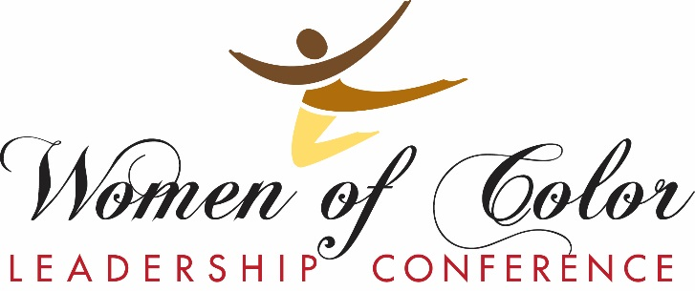

To: (Your Employer)
WOCLC Planning
Committee Members

Dr. Makini King | Diversity and Inclusion
Lona Davenport | Diversity and Inclusion
Dr. Michele Smith | Student Affairs
Dr. Kimberly Johnson | Multicultural Student Affairs
Keichanda Dees-Burnett | Multicultural Student Affairs
Danielle Martinez | Community
Raquel McCommon | DEI, School of Medicine
Doris Agwu | DEI, School of Medicine
Mako Miller | Deputy Provost Operations
Dr.Sally Ellis Fletcher | School of Nursing
Yvonne Hood | Diversity and Inclusion
Iesha Tyler | School of Medicine
Hannah Litwiller | Admissions
Mikah Thompson | Law School
Dana Middleton | Community
Zangi Miti | Community
Laneshia Neely | School of Pharmacy
Amanda Malone | UMKC Senior Student
From: (Your name)
Sponsorship Request: Participation in the Women of Color Leadership Conference
When: June 3rd, 2022
The 17th annual UMKC Women of Color Leadership Conference will take place on June 3, and I am seeking your financial support to attend the conference.
The WOCLC is a dynamic annual conference hosted by the Division of Diversity and Inclusion. Its mission is to provide an environment for, by and about Women of Color that promotes equity, education, and professional development in the Kansas City area.
Participation in this conference will allow me to:
- Strengthen cross-cultural leadership skills
- Understand the importance of developing and sustaining culturally competent skills
- Develop relationships and resources to continue professional and personal growth
- Enhance effective communication in diverse work teams
Individual registration for the conference is $75.00 and includes:
- Conference admission including a continental breakfast, breakout sessions, keynote luncheon and networking session on June 3

Thank you for considering this opportunity to sponsor my professional development. For further information on various conference sponsorship levels, visit www.umkc.edu/woclc

I look forward to your reply.
Regards,
(Your Name)

